**IFT 259: Introduction to Internet Networking**

**Lab 21  
Troubleshooting Scenario**

1. 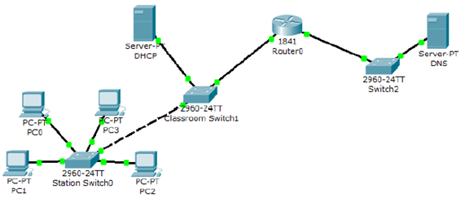Setup the following topology
2. Configure the DHCP server with the following IP address information

* IP address: 172.17.13.253
* Subnet Mask: 255.255.255.0 (NOTE: THIS IS NOT THE DEFAULT)
* Default Gateway: 172.17.13.1

1. Configure the DHCP server with the following DHCP pool information

* Default Gateway: 172.17.13.1
* DNS Server: 172.17.11.16
* Start IP Address: 172.17.13.10
* Subnet mask: 255.255.255.0 (NOTE: THIS MAY NOT BE THE DEFAULT)
* Max Number of Users: 30

1. Configure the DNS server with the following IP address information

* IP address: 172.17.11.16
* Subnet Mask: 255.255.255.0 (NOTE: THIS IS NOT THE DEFAULT)
* Default Gateway: 172.17.11.1

1. Configure the PCs to obtain an address automatically from the DHCP server
2. Configure the router with the following IP information

* FastEthernet0/0: IP Address: 172.17.13.1 Subnet Mask: 255.255.255.0 (NOTE: THIS IS NOT THE DEFAULT)
* FastEthernet0/1: IP Address: 172.17.11.1 Subnet Mask: 255.255.255.0
* Click on the Settings button on the Config tab.
* Click the Save button next to the NVRAM button to save your configuration on the Cisco Router. Failure to do this will cause your configuration to be lost when the router restarts

1. If everything has been configured correctly, you should be able to ping the “DNS” server from any of your PCs.

**Submit a copy of your successful ping for 2%**

**No successful Ping then submit a copy your topology for 1%**